
Member International Claim Form
for Microsoft (for claims outside the United States)
P.O. Box 91059
Seattle, WA 98111-9159
This form is to be used for medical, vision, and dental claims incurred outside of the United States.
Please note: Your claim will be returned if all of the information required below is not included. One member per claim form.
See instructions on the next page for additional information to complete your claim. Premera Blue Cross will not pay a bill submitted more than 12 months after the date of service.
1. Patient / Member
Premera Blue Cross ID card number  100077173 | Group number  1000010/1000049 |  | Prefix  MSJ |  | Patient name (first, middle, last)  Koviya S. Nath |  |  |  |  |  |  |  |  | Relationship to subscriber  Daughter
Subscriber name (first, middle, last)  Jishnu Nath |  |  |  |  |  | Patient date of birth (month/day/year)  6/24/1995 |  |  |  |  | Home phone number  4257470103
Address  2455 1³⁰th AVE SE |  |  |  |  |  |  |  |  | City  Bellevue |  | State  WA |  | ZIP  98005
Does the patient have coverage from any other health plan?
No, skip to section 2 Yes, please attach the Explanation of Benefits (EOB) statement from the primary plan with this claim, and complete the following information.
Name of other health coverage plan |  |  |  |  | ID number or policy number of other health plan |  |  |  |  |  |  | Phone number of other health plan
2. International Claim Details NOTE: You must submit an itemized bill or your claim will be returned. To expedite processing please provide translation and include proof of payment or point of sale receipt. Provide available medical records and complete this section.
In what setting were these services performed?
Inpatient hospital – Date of Admission: Date of Discharge:
Outpatient hospital Office/clinic Surgery center Skilled nursing center Home/lodging Other:
Name and complete address of servicing provider  Optical House |  |  |  | Country of service  India |  |  |  | Type of provider  Hospital Lab  Physician/Office X-ray |  |  |  |  | Date of service or purchase  Dec 31, 2012
What was the reason for obtaining medical treatment outside of the United States?  Travels |  |  |  |  |  |  |  | Billed charges  Rs. 16146.00 |  | Amount paid  Rs. 16146.00 |  |  |  |  | Foreign currency type  INR
Detailed description of illness and symptoms requiring treatment
Annual Vision
Detailed description of service and/or item purchased (per itemized charge). NOTE: Add additional sheet if necessary.
Prescription eyewear
Detailed description of service and/or item purchased (per itemized charge). NOTE: Add additional sheet if necessary.

Detailed description of service and/or item purchased (per itemized charge). NOTE: Add additional sheet if necessary.

3. Accident / Injury
Is this claim due to an accidental injury?  No, skip to section 4 Yes, complete this section |  | Date of accident |  |  |  |  | Where did the accident occur?  Home Work School Auto Other:
How did the accident happen?

Description of injury

4. Signature
To be accepted, this form must be fully completed (as appropriate to the claim being submitted), signed, and have itemized bill attached.

Mail to: Premera Blue Cross, P.O. Box 91059, Seattle, WA 98111-9159 or Fax to 800-676-1477
Please note: It is a crime to knowingly provide false, incomplete, or misleading information to an insurance company for the purpose of defrauding the company. Penalties include imprisonment, fines, and denial of insurance benefits.
Patient signature (or legal guardian if patient cannot legally consent to services) |  |  |  |  |  |  |  | Relationship to patient  Self  Other: Father |  |  |  |  | Date (month/day/year)  12/31/2013

Instructions

- Complete a claim form and attach the itemized bill. Please do not highlight or modify the itemized bill as this may cause delayed processing of your claim. To expedite processing please provide translation and include proof of payment or
point of sale receipt.
The itemized bill must contain all of the following information:
- Name of the member who incurred the expense.
- Name and address of the servicing provider and/or facility.
- Detailed description of illness and symptoms and/or diagnosis code. This information must be obtained from your provider.
- Detailed description of services and/or procedure codes and/or items purchased. This information must be obtained from
your provider.
- Date of service and itemized charge for each service rendered and/or items purchased.
Please note: Your claim will be returned if all information required above is not included. One member per claim form. The form
is not valid unless signed.
- If you have other coverage, attach a copy of the bills you submitted to the other plan and an Explanation of Benefits (EOB) you received from the other plan.

- The front of your member ID card may not match the card pictured below. This sample card is meant to be a guide to help you locate your identification number.
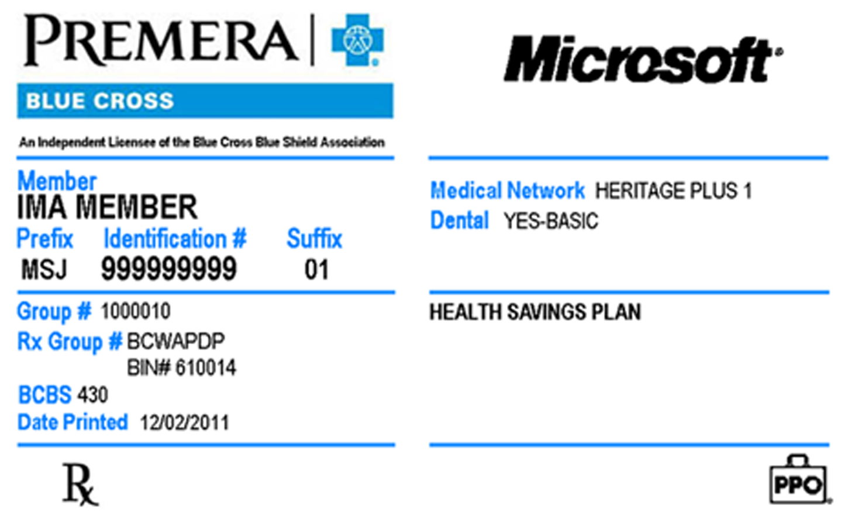

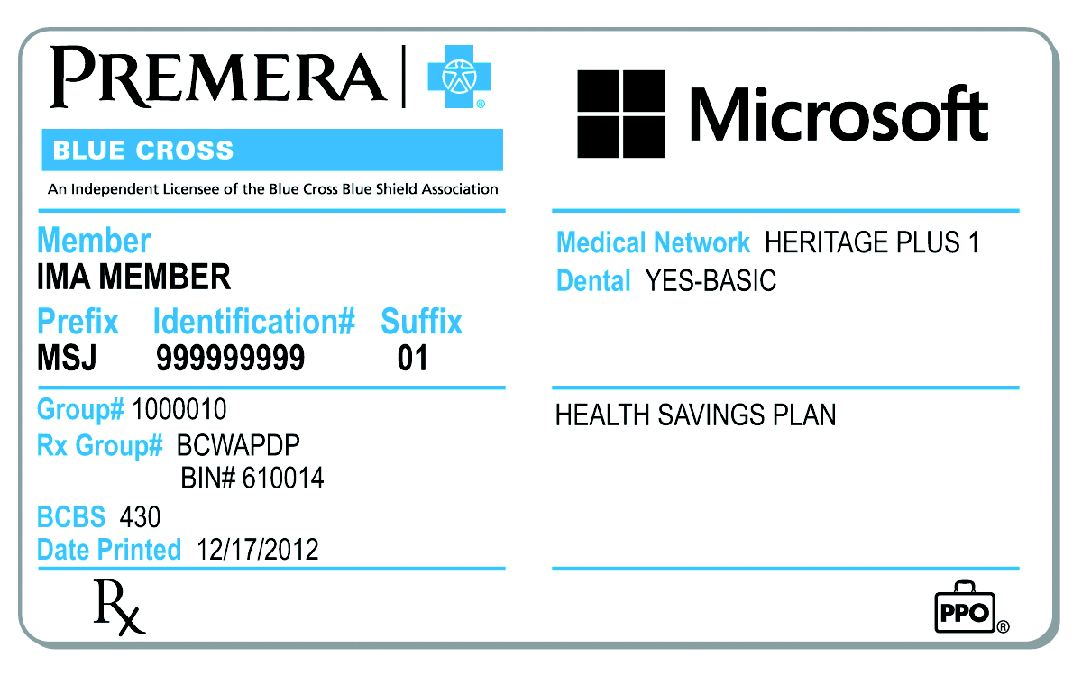

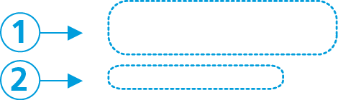

1 — Prefix and Identification # help us verify your eligibility,
determine your coverage and process claims.

2 — Group # identifies your plan’s benefits.

- Send the completed claim form and bills to:
Premera Blue Cross Customer Service: 1-800-676-1411
P.O. Box 91059 Fax: 1-800-676-1477
Seattle, WA 98111-9159 Email: claims.microsoft@premera.com

Please note: Premera Blue Cross will not pay a bill submitted more than 12 months after the date of service.

